Gin, btree, gist

Scripts: V19__Create.sql, V19.1__Insert.sql, V19.2__Create_Indexes.sql, test_gin.sql, test_btree.sql, test_gist.sql  
  
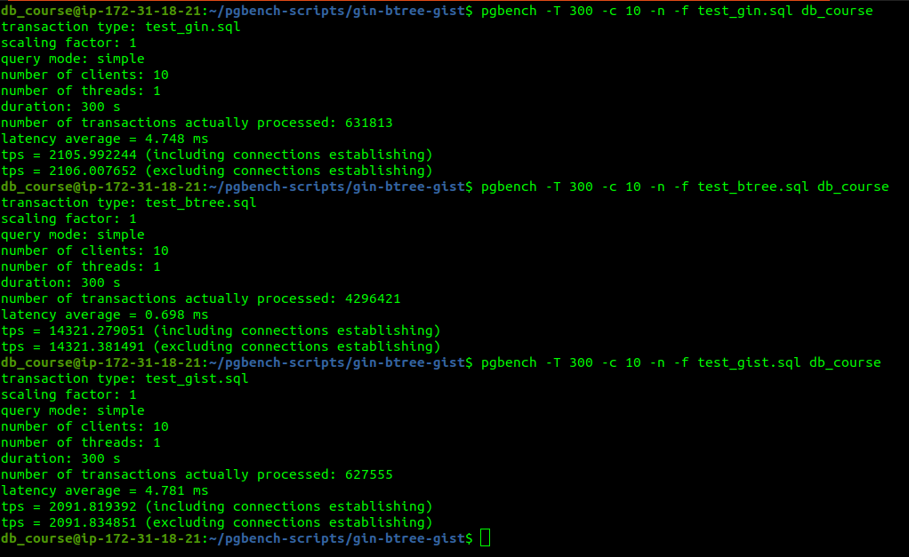  
index size:   
select * from pg_size_pretty(pg_relation_size((select indexrelid

from pg_stat_user_indexes

where relname = 't_gin')));

t_gin: tps = 2106.007652 index_size = 296 KB  
t_btree: tps = 14321.381491 index_size = 320 KB

t_gist: tps = 2091.834851 index_size = 592 KB